Geography

The skills we are focusing on in Geography are:

To understand geographical similarities and differences in the context of the UK.

To name, locate and identify characteristics of the four countries and capital cities of the UK and its surrounding seas.

To use world maps, atlases and globes to identify the UK and its countries.

To use aerial photographs to recognise landmarks and basic human and physical features.

RE

Our topic is Judaism.

* We will learn about the festival of Passover.
* We will reflect on the stories behind the celebrations and consider the importance of symbols and symbolic actions.

Computing

* To use technology purposefully to create, organise, store, manipulate and retrieve digital content.
* To manipulate an application window by moving and resizing it.
* To save work in a folder independently.
* To type sentences and save a document.
* Select, format text, change the size and colour of font and correct mistakes using the undo and redo buttons.

French

In French this term the focus will be on:

* Consolidate different greetings, numbers and colours.
* They will learn French words for different food and drink and how to say what they like.
* We will continue to focus on building confidence and authentic pronunciation using action songs and role-play.

History

Our topic this term is Victorians.

As Historians we will:

* look at and discuss real artefacts from The Victorian Age.
* sort objects from The Victorian Age.
* learn about Victorian school and identify similarities and differences to today.
* learn about the life of Queen Victoria.
* understand how the inventions of Victorians shaped our lives today.

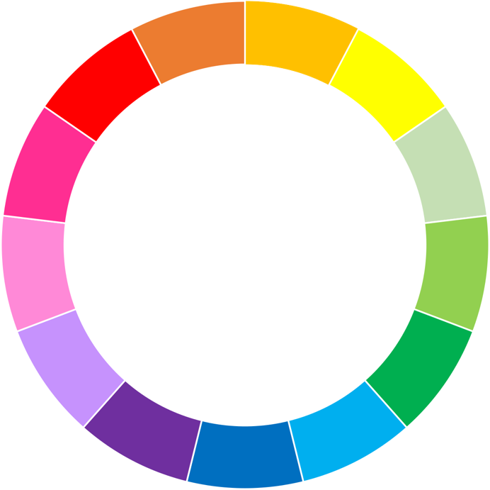

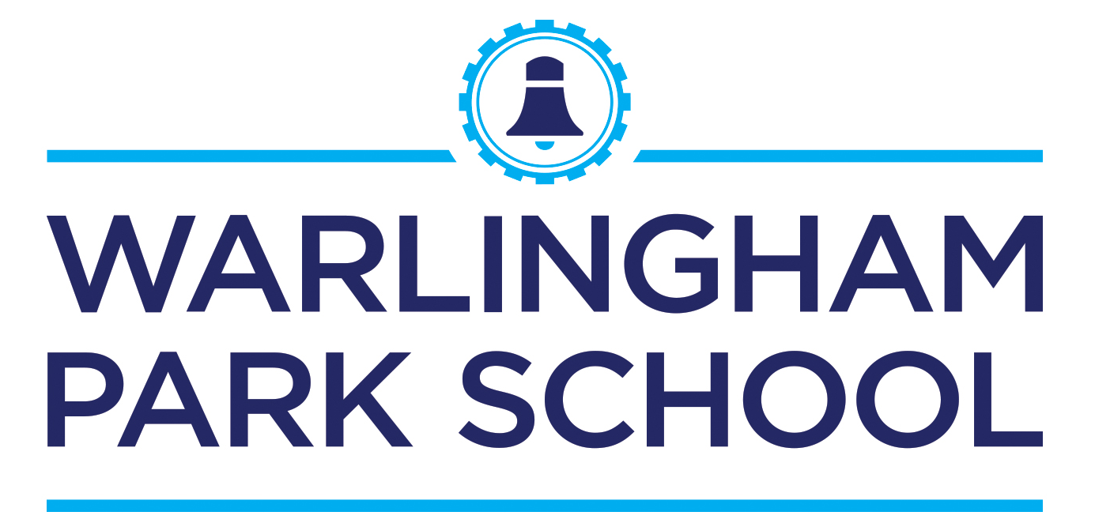

Year 2

Curriculum wheel

Spring Term

Learning to grow

PE

* Indoor: The children will continue to building on their Acro skills.
* Outdoor: This term the children are focussing on cricket skills.

Maths

As Mathematicians, we will:

* Multiplication and division: recall and use multiplication and division facts for the 2, 5 and 10 multiplication tables.
* Shape: identify and describe the properties of 2D and 3D shapes and compare and sort common 2-D and 3-D shapes and everyday objects.
* Money: recognise and use symbols for pounds (£) and pence (p) and combine amounts to make a particular value.

Science

As Scientists, we will learn about the uses of everyday materials:

* identify and compare the suitability of a variety of everyday materials and its uses.
* find out how the shapes of solid objects made from some materials can be changed.
* explore the properties of materials that make them suitable or unsuitable for particular purposes.

Performing Arts

Art

* To explore features of a self-portrait.
* To learn about William Morris and create artwork using intricate details as WM does.
* To create a piece of art using an ICT art program.
* To experiment with shading pencils.

Wellbeing

We will be learning about:

* What is a community and who keeps us safe.
* Understand and discuss how to keep safe.
* identify risks.
* know what to do in an emergency.

Design and Technology

This term the children will be designing and making a lighthouse which goes with our topic on explorers.

* To be able to draw and label a design which will suit a given purpose.
* To be able to discuss and select the most appropriate tools to use from a range given.

English

In English we will be working on:

* Traditional Fairy tales
* How to write instructions.
* Poetry
* Non-Chronological reports.

Our grammar focuses:

* Capital letters and full stops.
* Commas in a list.
* Use noun phrases in a sentence.
* Speech marks